Jenkins-Challenge-02
Create a Declarative Jenkins parameterized pipeline for simplecustomerapp.
Requirements:
- Create a Pipeline job in Jenkins.
Job name: simplecustomerapp-pipeline
Job type: pipeline
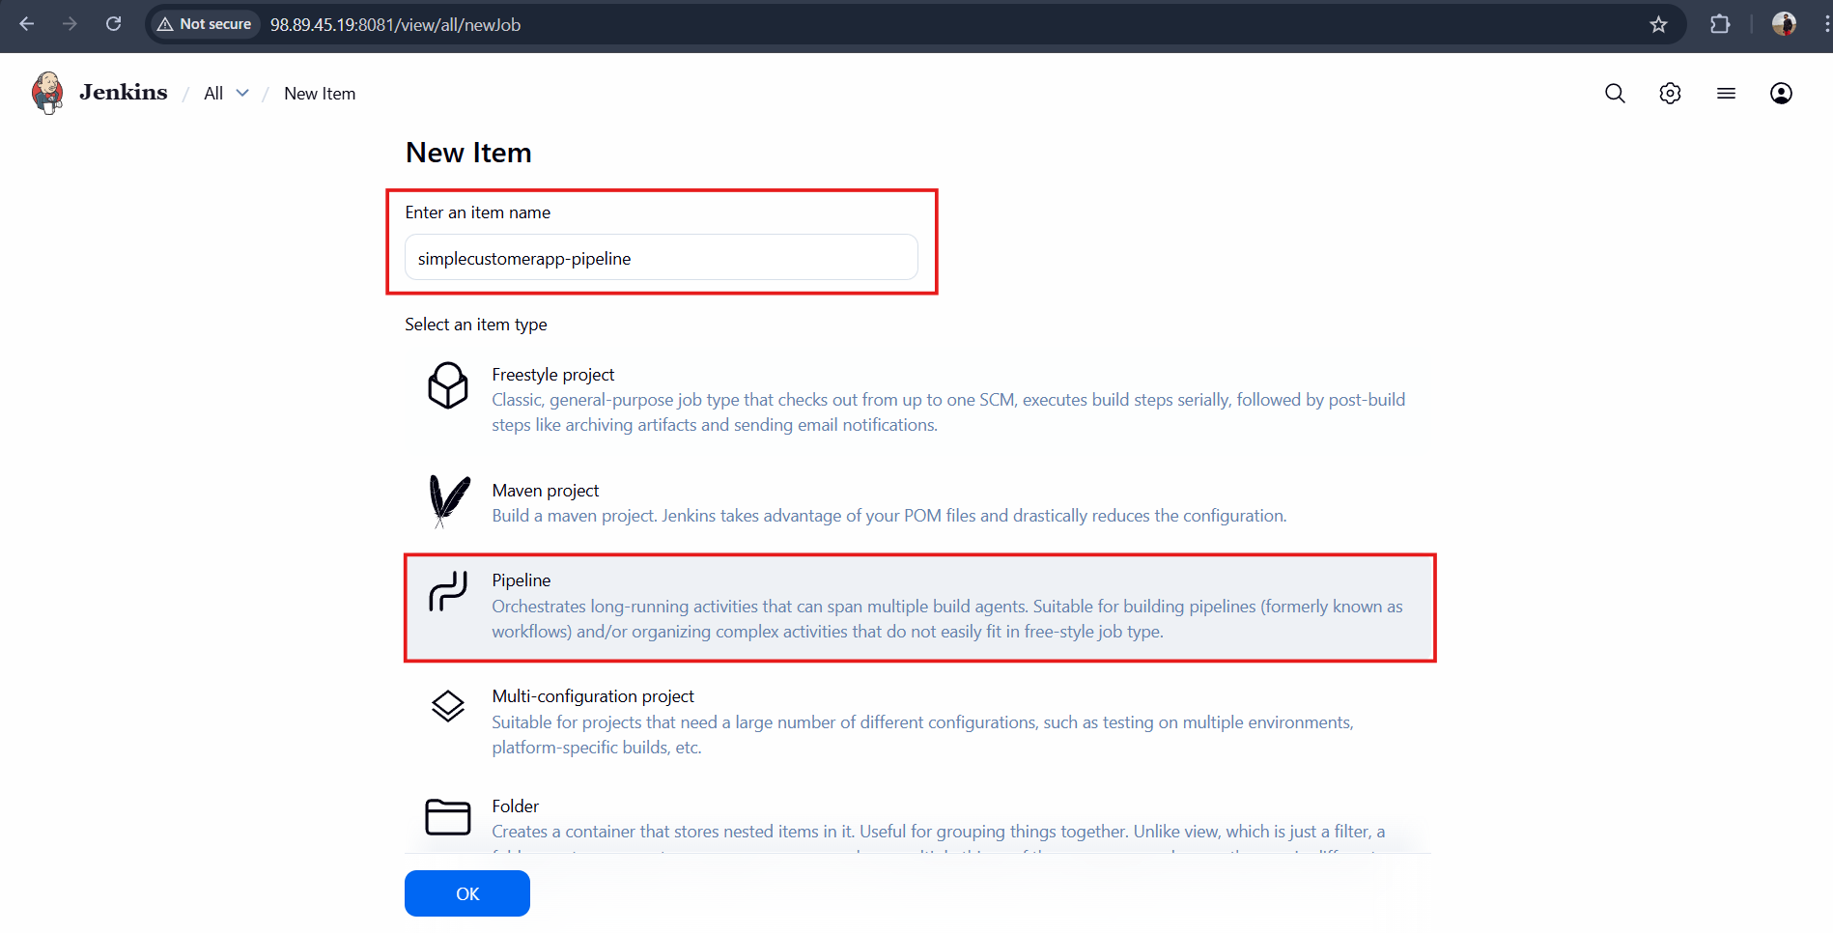

- Use a Git repository for simplecustomerapp.
https://github.com/shaikhshahbazz/sabear_simplecutomerapp.git
Goto
Pipeline Definition Select <Pipeline Script From SCM>
Select SCM <Git>
Script Path: Jenkinsfile
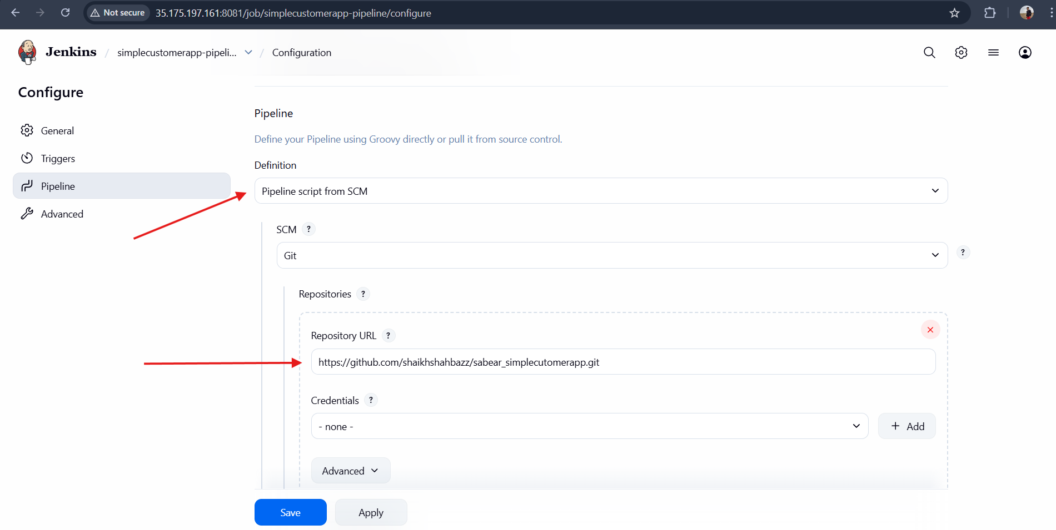
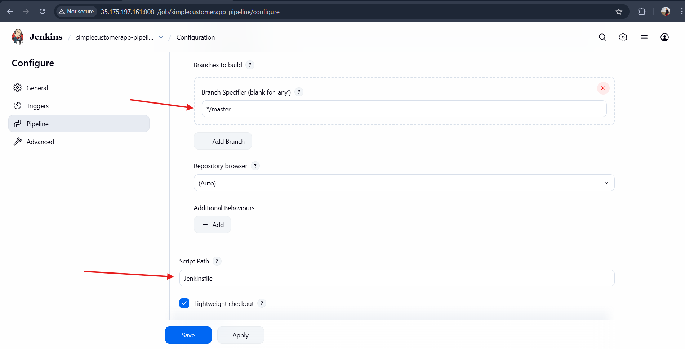

- Add parameters:
• BRANCH_NAME (string, default: master)
• ENV (choice: dev, qa)
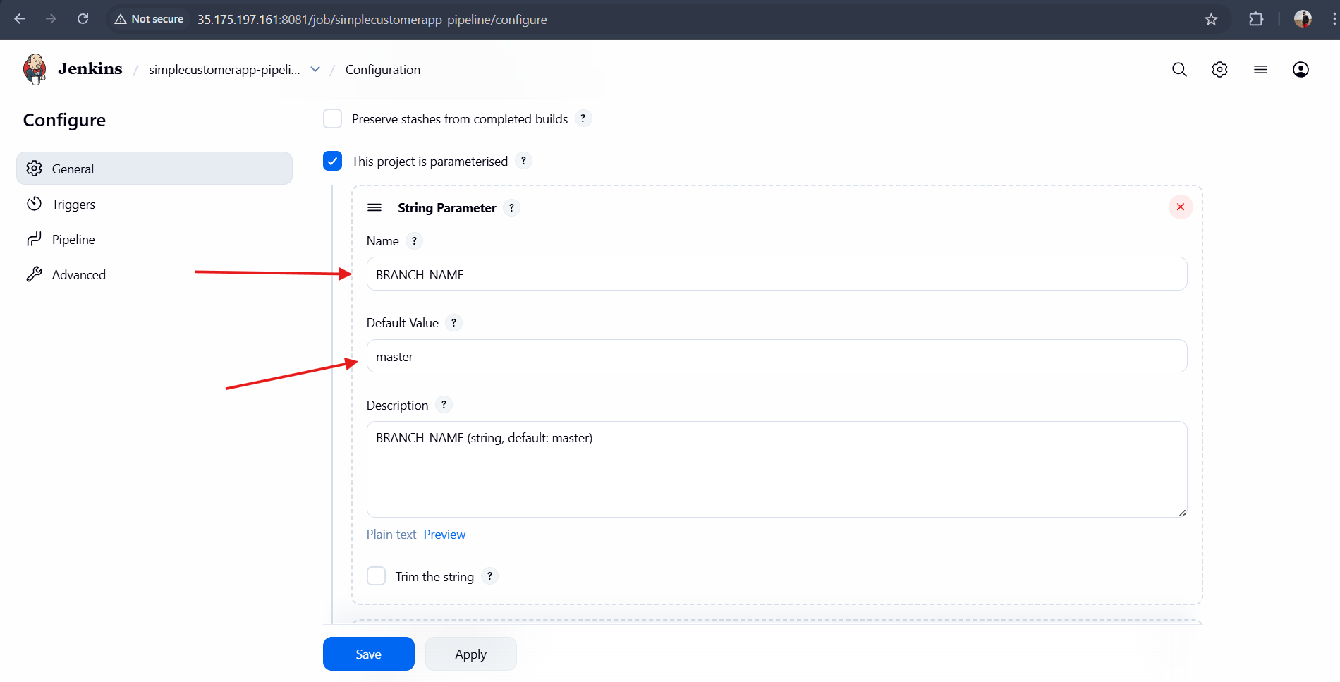

- Define environment variables:
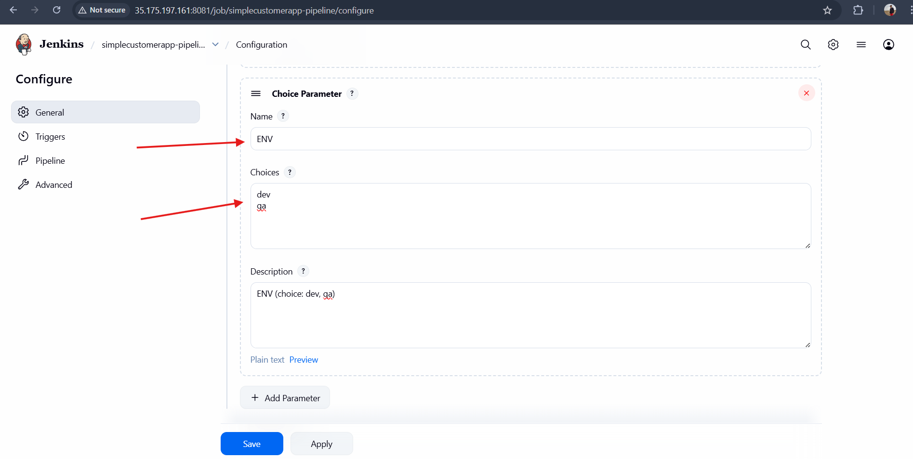
• APP_NAME = simplecustomerapp
- Implement stages:
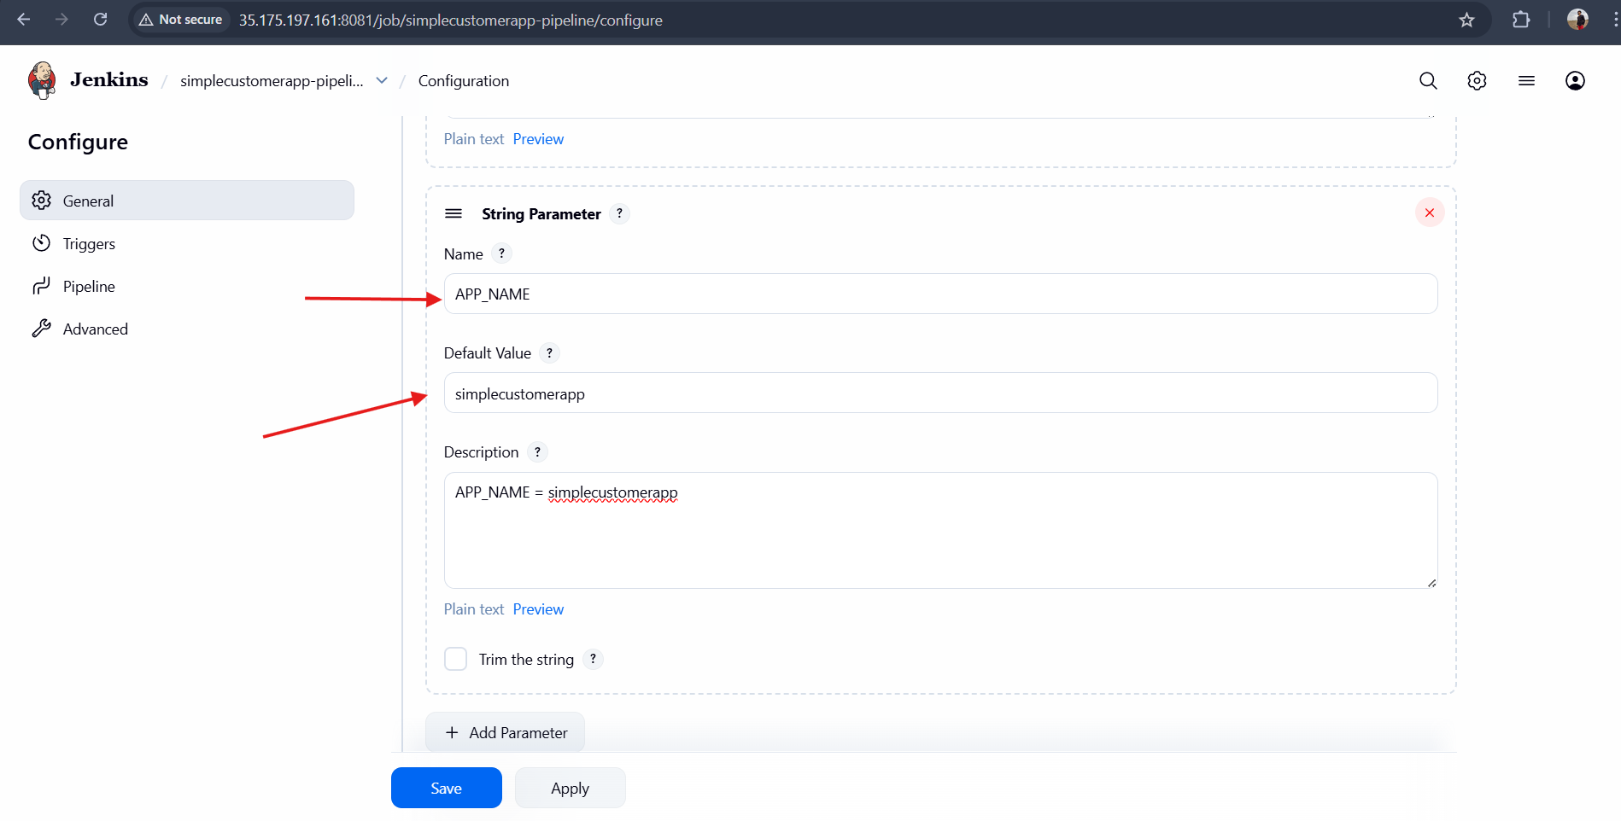
• Checkout (based on BRANCH_NAME)
• Build (mvn clean compile)
• Test (mvn test)
• Package (mvn package)
- Add post actions:
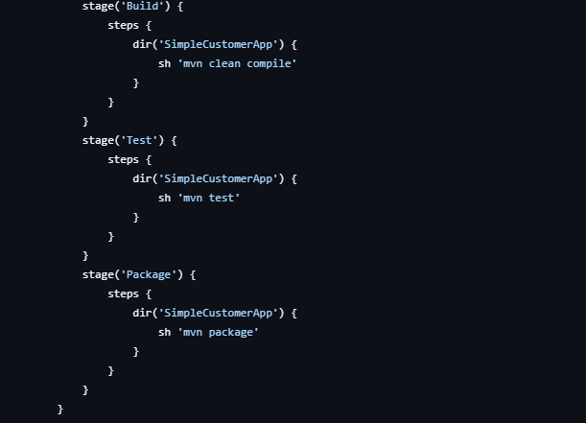
• Success → print success message with environment
• Failure → print failure message
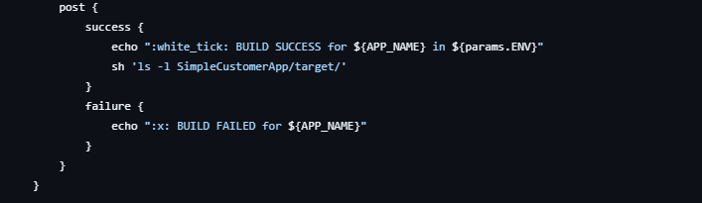
- Trigger using Build with Parameters.
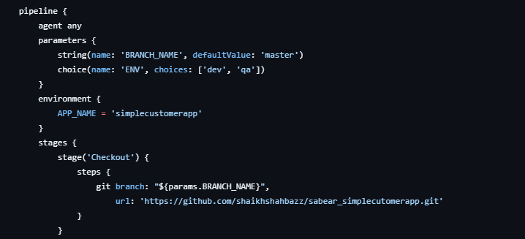
Jenkinsfile code:
pipeline {
agent any

tools {
maven 'MVN_HOME'
}

parameters {
string(
name: 'BRANCH_NAME',
defaultValue: 'master',
description: 'Git branch to build'
)
choice(
name: 'ENV',
choices: ['dev', 'qa'],
description: 'Target environment'
)
}

environment {
APP_NAME = 'simplecustomerapp'
}

stages {

stage('Checkout') {
steps {
echo "Checking out branch: ${params.BRANCH_NAME}"
git branch: "${params.BRANCH_NAME}",
url: 'https://github.com/shaikhshahbazz/sabear_simplecutomerapp.git'
}
}

stage('Build') {
steps {
sh 'mvn clean compile'
}
}

stage('Test') {
steps {
sh 'mvn test'
}
}

stage('Package') {
steps {
sh 'mvn package'
}
}
}

post {
success {
echo "BUILD SUCCESSFUL for ${APP_NAME} in ${params.ENV} environment"
}
failure {
echo "BUILD FAILED for ${APP_NAME}"
}
}
}
Build with parameters:
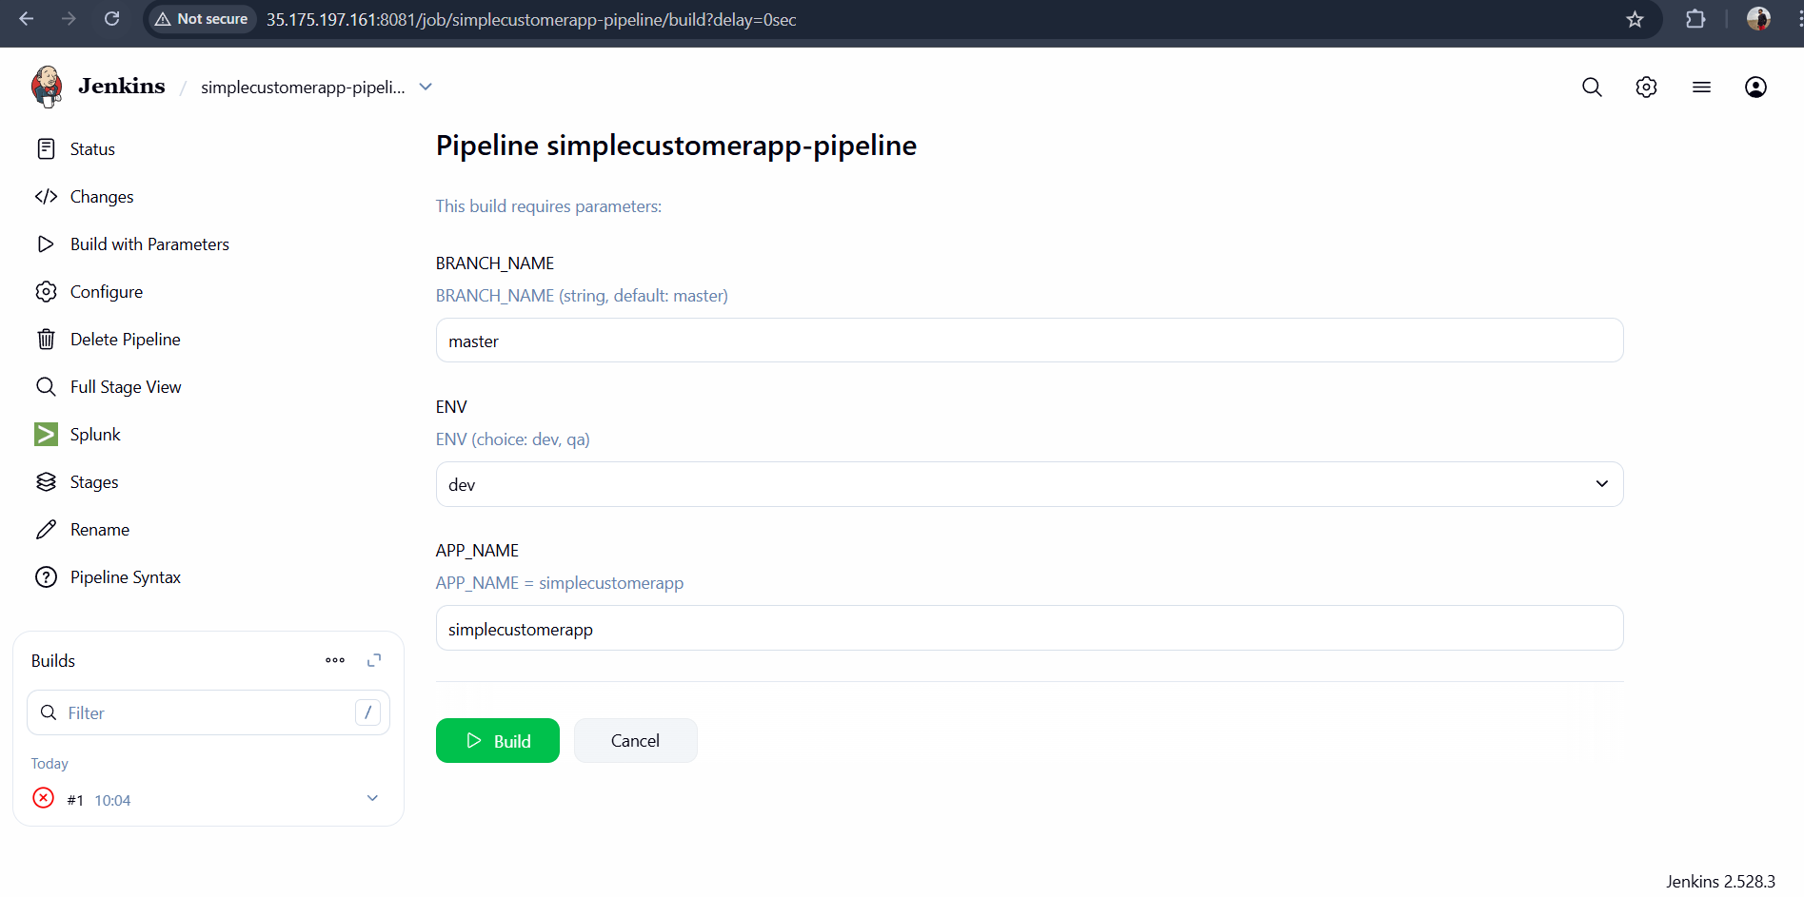
Outcome
• Parameterized Jenkins pipeline created
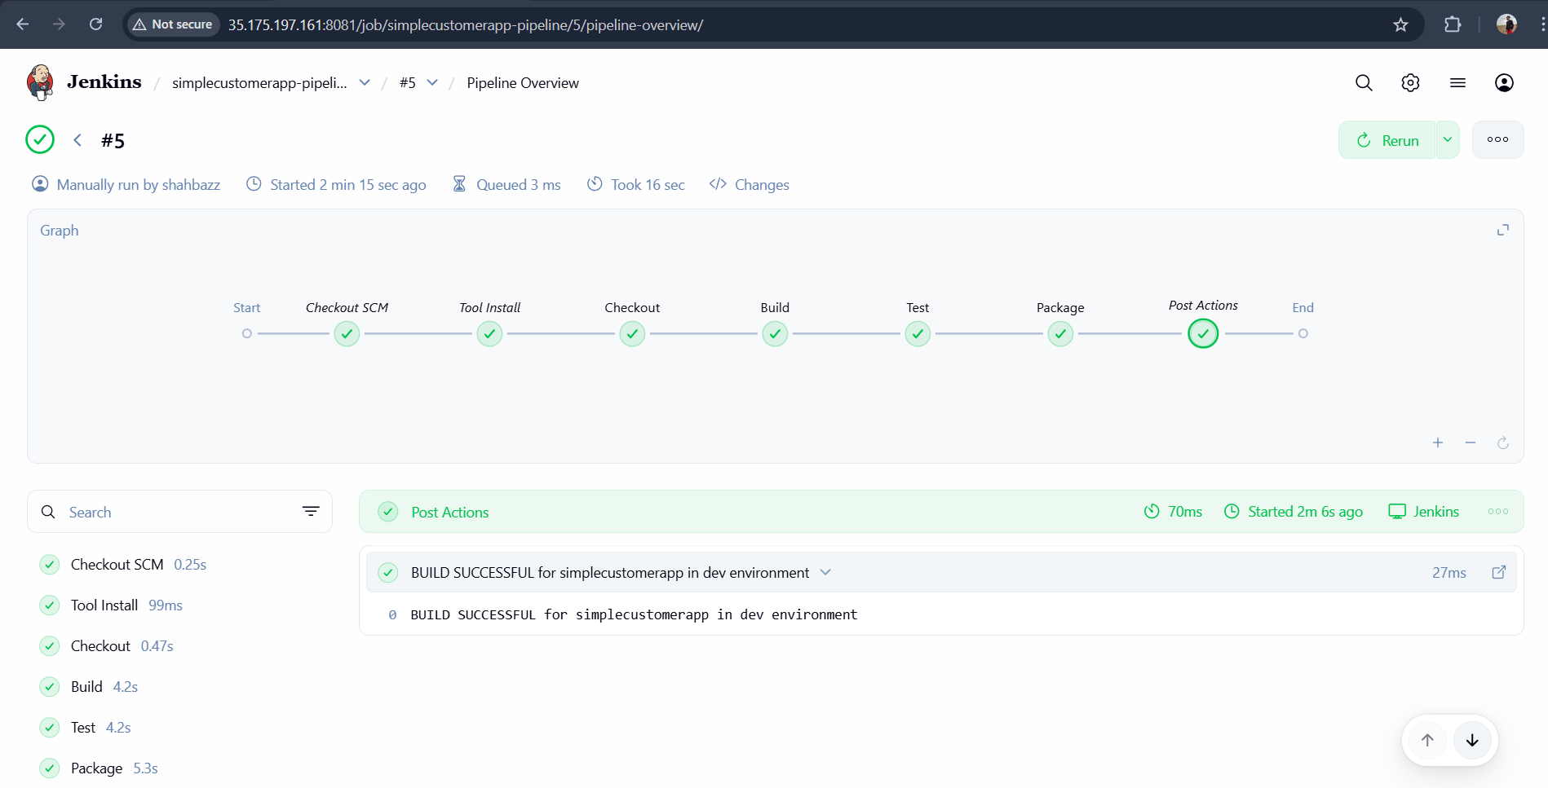
• Code is built, tested, and packaged automatically
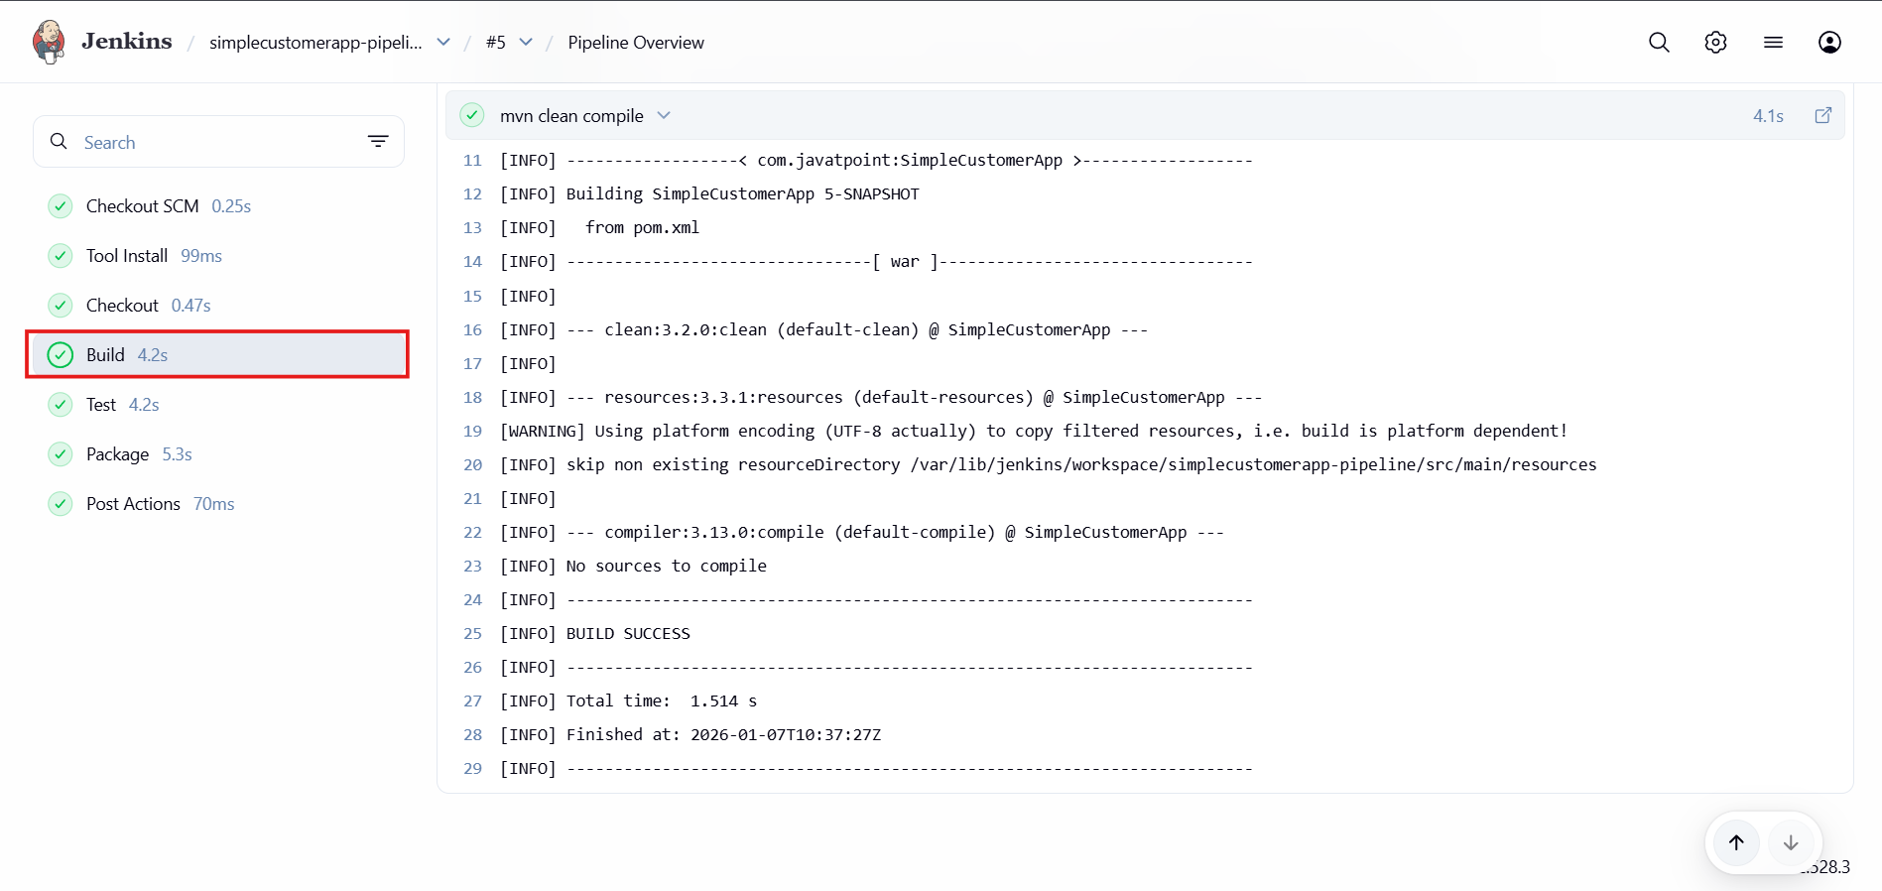
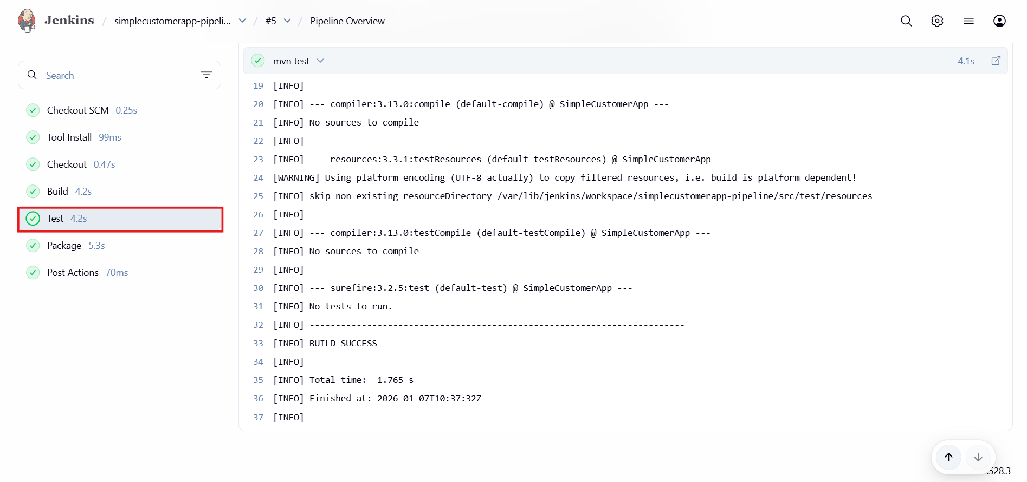
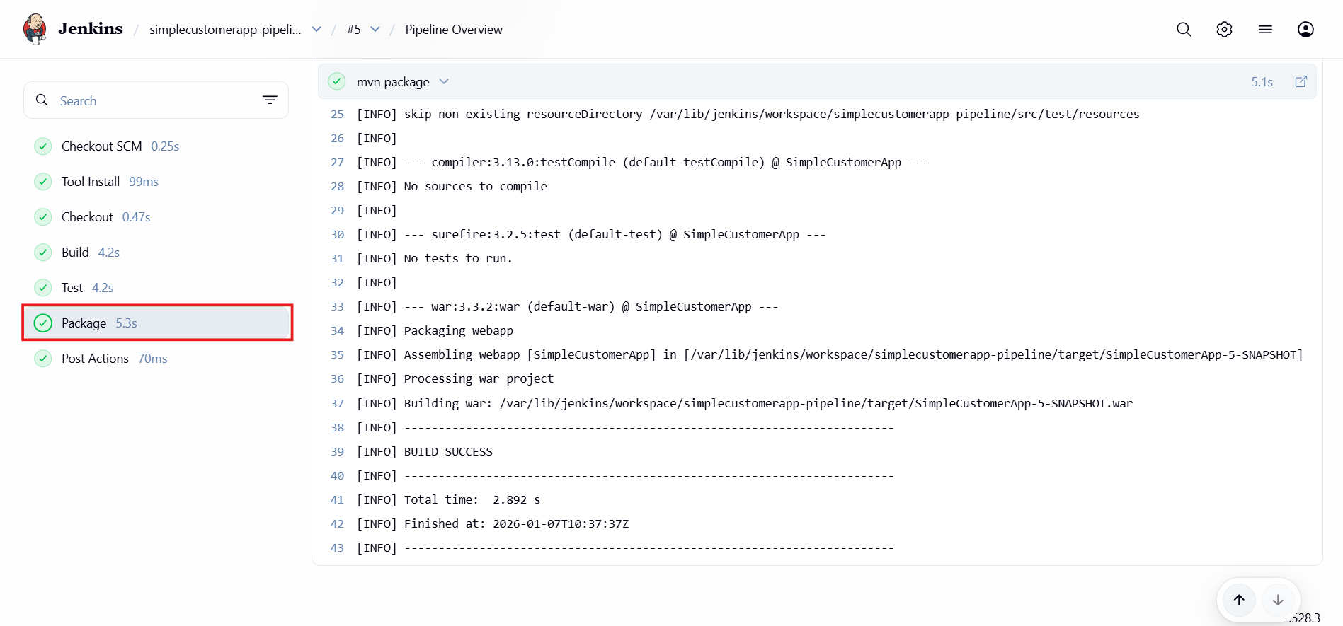
• JAR file generated in target/
We need to edit pom.xml file in GitHub repo
Replace the <packaging>war</packaging> to <packaging>jar</packaging>
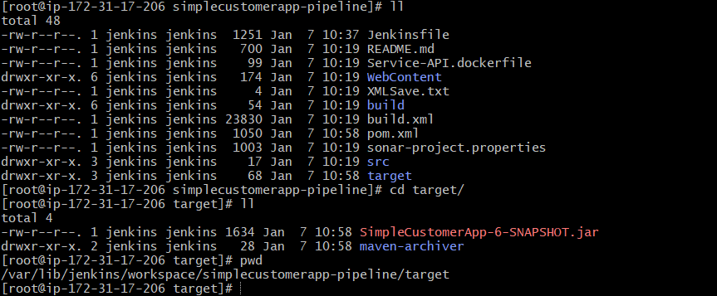
• Clear visibility of build stages and logs
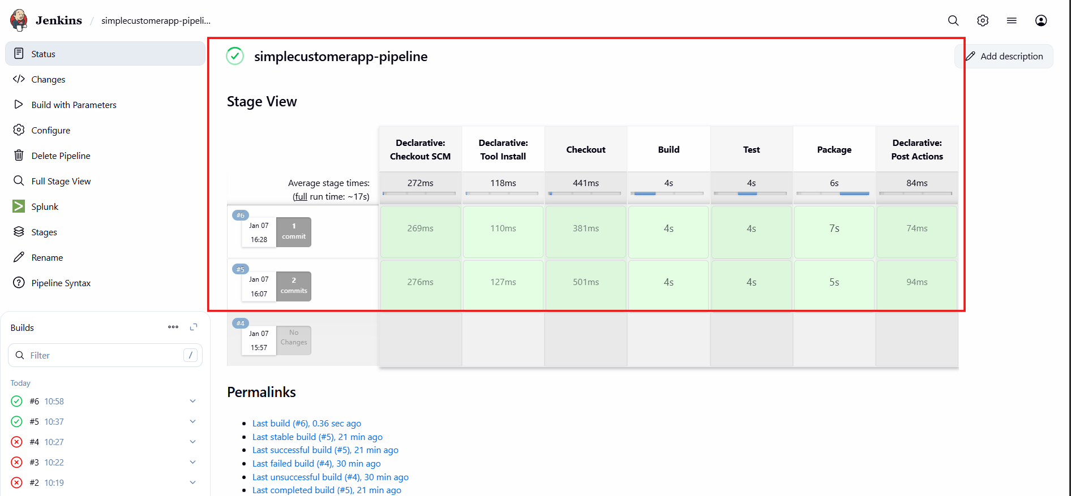
• Single pipeline works for multiple environments
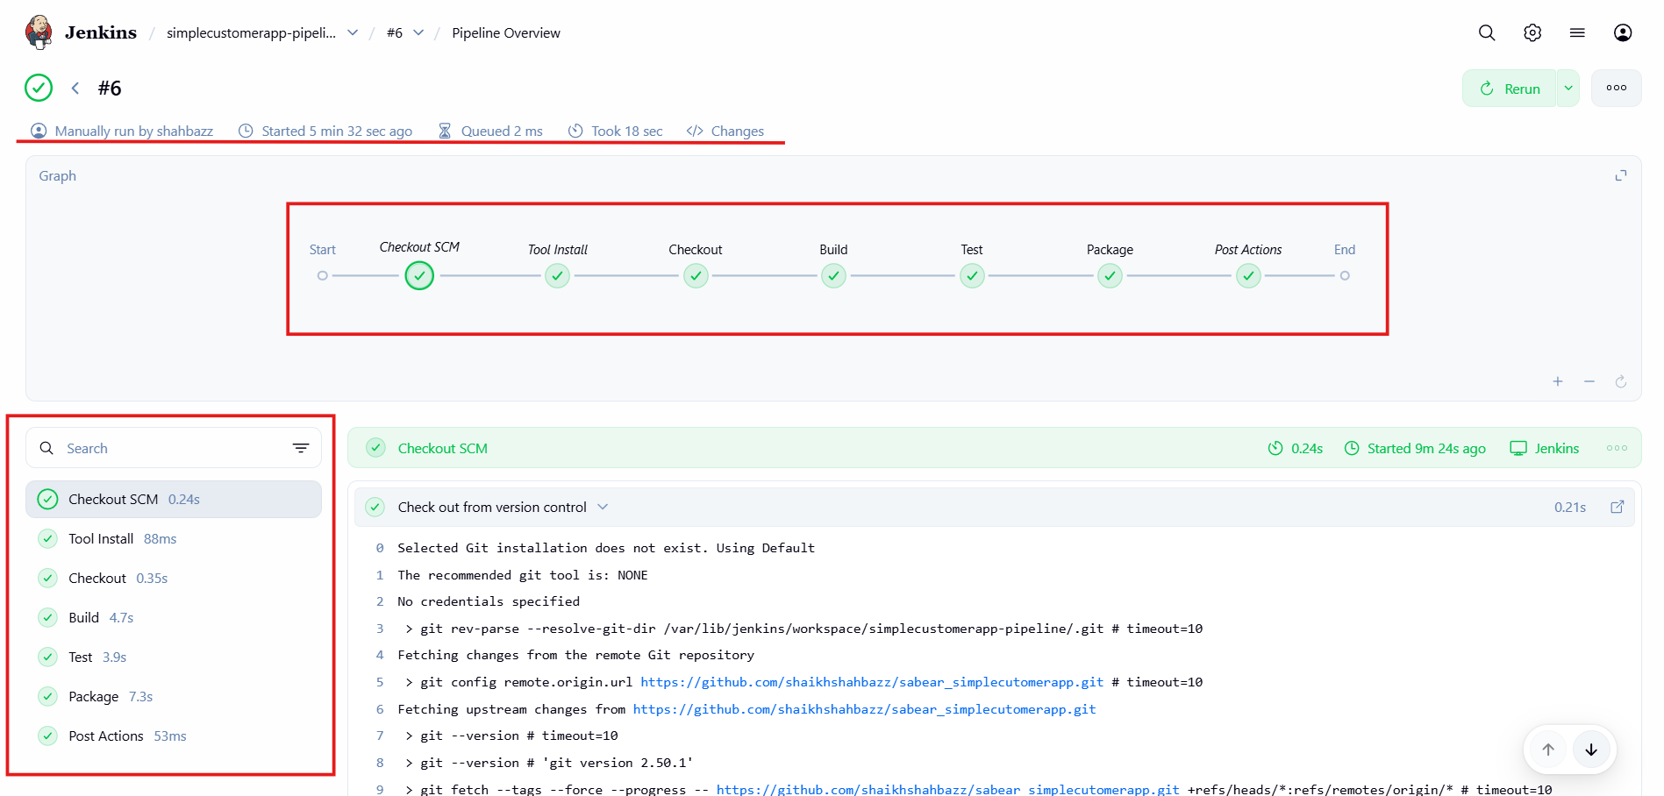
Advantages
• One pipeline can be reused for different branches and environments
• Reduces manual build and deployment effort
• Early test failures stop bad code from moving forward
• Easy to maintain and extend (SonarQube, Docker, Deploy stages later)

